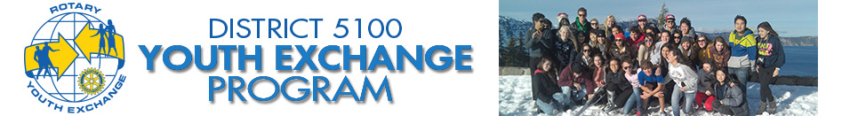
Why Youth Exchange?
For over 75 years, students and host families have broadened their horizons through Rotary Youth Exchange. More than 80 countries and over 8,000 students participate each year in the program, which is administered at the regional level by Rotary districts and at the local level by Rotary clubs.
Globally Minded
Rotary clubs are made up of volunteers who are involved in community service, emphasize high ethical standards, and work toward peace and understanding in the world. Over 1.2 million Rotarians in more than 32,000 clubs create the extensive network that provides support for Youth Exchange.
A Commitment to Youth
Rotary maintains a strong connection to youth and young adults. Besides Youth Exchange, Rotary clubs sponsor youth service clubs such as Interact, Rotaract, and RYLA and offer career development and mentoring programs. Rotary is committed to creating and maintaining the safest possible environment for all participants in its programs, including Youth Exchange.
Low cost
Rotary club volunteers administer the program at the local level, which helps keep costs low for students and their families. These volunteers often offer years of experience with students, host families and fellow Rotarians who are involved in the program.

Rotary Youth Exchange: It’s the opportunity of a lifetime.
Are you ready for it?

