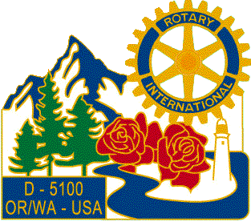

Greetings!
The Salem area Rotary Clubs and Rotary Youth Exchange invites you to consider being a host family for an international high school student. Families host students for 3-6 months during the school year. It is a wonderful opportunity to get to know another culture and make a lifetime friend for your family.
Please join us for an informational evening on Monday, May 2nd, 6-8pm, at Broadway Commons, located at 1300 Broadway Street NE – Peru Room, 3rd Floor. You’ll have a chance to meet Rotary exchange students from various countries and experienced host families. Free pizza included!
RSVP to www.eventbrite.com (search Rotary Youth Exchange Pizza Gathering) by May 1st and feel free to pass this flyer on if you know someone who may be interested in hosting.

Thank you!

